**The Hong Kong Polytechnic University**

**Laboratory Report**

**MECHANICS OF MATERIALS**

**ME33001_20222_A**

**Structural Design and Optimization of Beam for Higher Load Bearing Capacity under Three-Point Bending**

**(February 2023)**

Name: QIN Qijun

Student ID: 21101279D

**Abstract**

This experiment aims to design and perform three-point bending experiments on the beam. The cross-sectional designs of H-Beam and Hollow-Rectangular were discussed, and the highest cross-sectional design of Force/Mass and the optimal dimensions were derived using Pure Bending and Zhuravskii shear stress theories combined with enumeration algorithms. The printed beam model was subjected to a three-point bending test and the material, cross-sectional and structural properties were summarized. Finally, based on the experimental feedback data and combined with the Euler's Critical Load and Lateral Torsion Buckling theory, the design method and algorithm were readjusted and derived a better design and calculation model.

**Contribution to the Project**

Responsible for most of the theoretical and formulation studies, mainly including normal bending stress, Euler's Critical Load and Lateral Torsion Buckling theory, as well as many more theories and formulations that have been studied but not well implemented. In addition, responsible for all code design, most of the modeling, and most of the finite element simulations.

1. **Introduction**

Beam is an important load-bearing structure and its load-bearing capacity depends on the type of material, structural design and the properties of the load. Since the beam is not an ideal rigid body, the mechanical analysis must consider not only the effects of external forces on the structure, but also the effects of internal stresses and strains in the beam. Therefore, the structural design of the beam is essential.

For the design of the beam structure, the key is the design of its cross section. The design process considers whether the stresses or strains within the beam are beyond the capacity of the material during the stresses and whether the structure is stable. To consider these factors, the Pure Bending Theory, Zhuravskii Shear Stress Formula, Euler's Critical Load and Lateral Torsion Buckling are used. Therefore, the beam design level in this experiment will be discussed around these aspects.

The three-point bending test is designed to verify that the beams meet design expectations. In addition, the collected experimental data will be further investigated and summarized to determine the maximum force, maximum deflection, normal stress, and shear stress of the structure, as well as its material properties, fracture mechanism, and stability.

Finally, the experimental results are used to further improve the design approach and algorithm and to derive a more comprehensive design theory model.

1. **Original Beam Structure Design**
   1. **Cross-section type selection and analysis**

Since the experiments are evaluated in terms of force/mass, the target symmetric section needs to have a large moment of inertia in the strong axis to enhance its bending resistance. At the same time other sections should be reduced as much as possible to reduce the mass of the beam.

H-Section and Hollow Rectangular were selected for the final cross-section.

Figure : H-Section and Hollow Rectangular-Section

These two cross-sectional beams are widely used in production, and both have high bending resistance and small cross-sectional area.

* 1. **Material Properties**

This experiment uses a 3D printing method to build the beam model in kind. The following are the properties of this 3D printing material.

|  |  |
| --- | --- |
| Elastic Modulus () | 2.2 GPa |
| Poison Ratio () | 0.4 |
| Shear Modulus () |  |
| Density () | 1.05 g/cm |
| Yield Strength () | 31 MPa |
| Elongation at Yield () | 2% |
| Tensile Strength () | 33 MPa |
| Elongation at Break () | 6% |

* 1. **Beam Analysis**

The following are the specifications of the beam and the dimensions of the three-point bending test:

Figure : Specifications of the Beam and the Dimensions of the Three-point Bending Test

Simplify it as

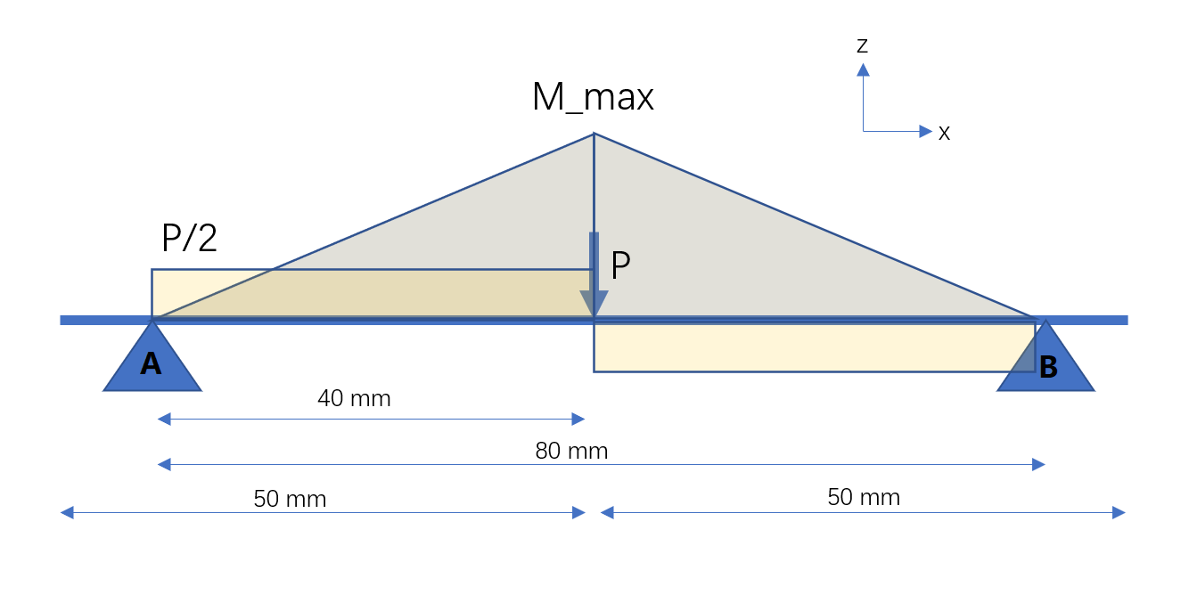

Figure : Equivalent Force and Moment in Beam

Here we have

where is the load exerted by the center in the three-point test, is the total length of the beam that is equal to 100 mm, and is the support on base fixture, is the moment of the beam in the center.

* + 1. **H Beam**

Here is the shape of H-Section:

Figure : H Beam Design [1]

The relationship between the applied at the center of the beam and the center moment has been obtained in 2.3 above, and following analysis just consider the center of the beam. Then, to calculate the maximum normal stress at the center of the beam, use Pure Bending Formula:

where

,

Next, consider the shear force. According to Zhuravskii Shear Stress Formula, we have:

where

t is the thickness of the web.

With the above equation, we can calculate the internal normal and shear stresses in the H Beam when subjected to the central load P.

* + 1. **Hollow Rectangular Beam**

Here is the shape of Hollow Rectangular:

Figure : Hollow Rectangular Beam Design [1]

Similar to H Beam, first calculate the bending normal stress:

where

,

Next, calculate the shear force:

where

With the above equation, we can calculate the internal normal and shear stresses in the Hollow Rectangular Beam when subjected to the central load P.

* 1. **Enumeration Algorithm to Find Optimal Size**

By using the above equation of 2.3 we can know the magnitude of the internal stress under the application of a certain P-load. Since the known conditions are yield stress and fracture stress, we can back-calculate the maximum bearing force at a certain size.

And its size can be enumerated by listing all the possible sizes and finding the size with the maximum Force/Mass. Constraints include:

Back calculate the maximum applied load from the normal and shear stresses corresponding to the currently enumerated size, and use the smallest load as the ultimate load for that size. Finally, compare all the ultimate loads and select the size of the maximum ultimate load.

Different graphs require different enumeration algorithms. Please refer to Appendix B for the specific implementation method.

* 1. **Result**

According to the records of that time, we got the following data:

|  |  |
| --- | --- |
|  | H Beam |
| b | 38.5 |
| s | 2 |
| h | 34 |
| t | 2 |
|  | 56498.0 |
| Area | 222 |
|  | 4609.047368421053 |
| Force/Mass | 197728.32983359302 |

|  |  |
| --- | --- |
|  | Hollow Rectangular Beam |
| b | 38 |
| d | 38 |
| h | 34 |
| k | 30 |
|  | 97261.33333333333 |
| Area | 424 |
|  | 7934.4771929824565 |
| Force/Mass | 178222.75815324477 |

Based on the above data, we can see that since the best Force/Mass of H Beam is larger than that of Hollow Beam, we finally choose H Beam and design with that size.

The final design of H Beam is shown as:

图示

Figure : H Beam Design

1. **Three Point Test**
   1. **Tester Parameter**

The structure that was designed is placed directly on a bracket located 80 millimeters away. Subsequently, a compressive load is gradually applied at a rate of 2 millimeters per minute until the structure reaches failure.

* 1. **Performing Test**

Place the printed structure in accordance with the prescribed diagram (See figure 2) and start the tester. Then, the tester start to apply load, record the data including Load and Deflection, and draw the graph.

* 1. **Test Result**

Here is the data of the test:

Figure : Load-Deflection graph for 3 points bending of H Beam

The curve reflects the obvious characteristics of a brittle material, which does not have a significant lengthening process after reaching the yield point, but fractures instantly.

* 1. **Result Analysis**

By analyzing the data, we find that the maximum force it can withstand is much less than the calculated value, where .

According to the situation at the site, the fracture of the beam was not a fracture due to the strong axis bending direction, but a lateral torsional fracture due to instability. (See Figure 8 below)

桌子上摆放着黑色的机器

Figure : Failure Patterns of H Beam in Actual Test

Therefore, the failure mechanism of this structure may be due to the fact that the vertical force on the structure exceeded the critical buckling load of the web, which caused the web to buckle and fracture instantaneously.

In addition, after revalidation of the data after the experiment, it was found that the part of the algorithm that calculates shear stress uses the wrong dimension, which eventually led to the algorithm not being able to take shear stress into account in the design.

After making the correction, we get the new comparison data:

Figure : comparison of Experimental data and designed normal & shear stress.

where .

Based on the new experimental data, we performed finite element analysis (FEA) to verify. Here is the result of FEA. We can find that when the applied force reaches about 2565N, the stress on the neutral axis basically reaches its shear strength and thus fracture occurs.

Figure : FEA VonMises Stress Result

However, the fracture in the real case still occurs before shear stress. Therefore, more factors need to be considered for the experiment. More discussion will be given below.

1. **Improvement of Design Approach**
   1. **Theoretical Design**

Based on the experimental results, it is determined that the design method also needs to consider the buckling of the beam, so a new theory is proposed.

Since the buckling failure of H Beam may be of the following form:

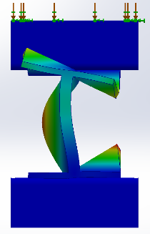

Figure : H Beam Buckling on web.

Euler's Critical Load can me consider. Euler's Critical Load considers the beam becoming unstable and deforming when the load along the axis reaches a certain level.

Consider following web:

形状

Figure : Web of H Beam

For simplicity to facilitate the calculation, it is assumed that the applied force is uniformly applied to the top of the web, and only the 2D plane where the section is located is considered.

画里面的卡通人物

Figure : Simplified 2D plane

According to the Euler's Critical Load formula:

where

is the column effective length factor. For web, it is both ends pinned. is the total length of the beam, is the thickness of the web.

Re-analysis of the experimental results revealed that the beam is:

Compare with the test graph:

This shows that the load at the time of the test exceeded the Pcr and buckling occurred. Since the material is brittle, it fractures immediately at the moment of buckling. Thus, it is confirmed that the premature fracture of the designed H Beam is strongly related to the occurrence of buckling. From this, the beam design method also needs to consider buckling factors.

In addition, the Lateral Torsion Buckling theory can also be considered. Lateral Torsion Buckling considers the lateral deflection and torsion caused by instability when the beam is bent to a certain degree.

The relevant formula is as follows:

Figure : Lateral Torsion Buckling formula [3].

Convert to load:

The above specific parameters will be placed in the Appendix A.

Through the above processing, a new comprehensive design method model was finally obtained.

* 1. **New Calculation Method Model Calculation Results**

After recalculating the H Beam, bellowing is the result:

|  |  |
| --- | --- |
|  | H Beam |
| b | 32.5 |
| s | 2 |
| h | 34 |
| t |  |
|  |  |
| Area | 266.0 |
|  | 4508.43 |
|  | 4526.86 |
|  | 10017.59 |
|  | 10543.32 |
|  | 4508.43 |
| Force/Mass | 161419.02 |

It can be noted that the new algorithm thickens the thickness of the web from 2mm to 4mm. And the flange is shorter in width, probably to reduce the area to increase the Force/Mass value.

In addition, the Hollow Rectangular is recalculated using the traditional calculation method after the corrected dimension. Bellowing is the result:

|  |  |
| --- | --- |
|  | Hollow Rectangular Beam |
| b | 32 |
| d | 38 |
| h | 26 |
| k | 32 |
|  | 75328.00 |
| Area | 384 |
|  | 6541.64 |
|  | 6608.87 |
|  | 9541.84 |
|  | 6541.64 |
| Force/Mass | 162243.11 |

Compared to the original design, it is smaller in width and taller in height. This may be to increase its moment of inertia.

Here is a comparison of the measurement model before and after the recalculation. The left side of each type is the initial design, and the right side is the redesign:

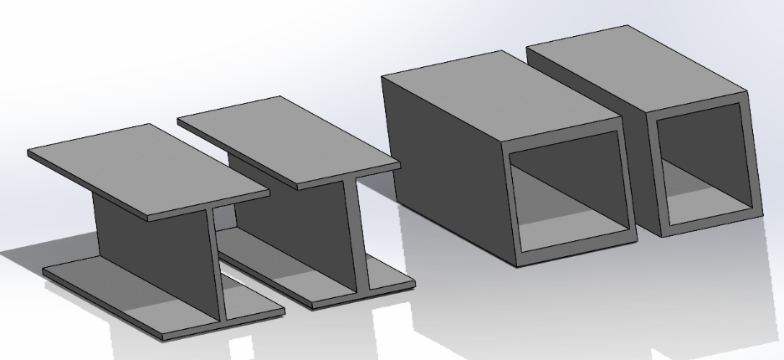

Figure : Comparison of initial design and redesign of Hollow Rectangular Beam and H Beam

After recalculation, it is found that the maximum Force/Mass of Hollow Rectangular is greater than that of H Beam. In addition, Hollow Rectangular has a higher load carrying capacity under the condition that Force/Mass is very similar, so it is better to choose this section. At the same time, the maximum bearing force becomes smaller after correcting the dimension and adding the buckling theory, so it is inferred that the shear force and buckling also have a great effect on the design of the beam.

* 1. **Finite Element Simulation (FEA)**

Based on the finite element analysis, we developed a general failure evaluation and output the stress or strain diagram at the moment of failure. The following is the specific analysis.

* + 1. H Beam FEA Result

The following is a graphical representation of the stress distribution of H Beam.

Figure : FEA normal stress distribution diagram of H Beam.

After analyzing the normal stress, shear stress, and strain in each direction of the graphical solution, it is finally found that the normal stress reaches the limit first. The magnitude of the applied load at this moment is

* + 1. Hollow Rectangular FEA Result

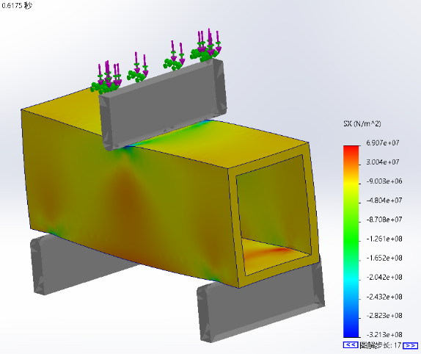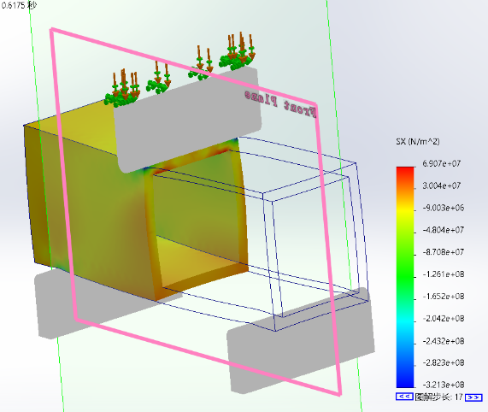

Figure : FEA z-axis strain distribution diagram of Hollow Rectangular Beam.

After comparative analysis, the mechanism of the final failure of Hollow Rectangular also due to the normal stress reaches the limit. The applied load at this moment is .

* + 1. FEA Result Analysis

Through the above analysis of FEA, it can be found that after fully considering the conditions of Shear Stress and Buckling, the shear stress generated by these structures due to the force is greatly reduced, which significantly reduces the structural failure due to shear force. At the same time, Buckling is less likely to occur, making the overall structure more stable. The ultimate failure determinant is dominated by the normal stresses generated by pure bending, which greatly exploits the advantages of the strong axes of the structure in resisting bending and loading.

In addition, the ultimate loads that these structures can withstand in the FEA are greater than the designed ultimate loads and at the same time smaller than the largest of several calculated forces, so the validity and reliability of the calculation theory can be proved to some extent. Of course, since the actual ultimate load basically exceeds the design load by 40%-50%, there is still room for optimization.

1. **Conclusion**

The design of beam structures often requires a combination of theories to be analyzed together to ensure the capacity and stability of the beam to carry the load. In practice, the beam does not ideally bend along the strong axis, but may also experience lateral torsional buckling, which requires multiple analyses. Since the material is brittle, its brittle nature also needs to be considered in the analysis.

This experiment analyzes and verifies the effectiveness of Pure Bending Theory, Zhuravskii Shear Stress Theory, Euler's Critical Load and Lateral Torsion Buckling in the design and analysis of crossbeam structures, covering both ideal bending and lateral torsional buckling of beams. These theories are successfully combined to achieve a more comprehensive consideration of beam design.

In addition, an enumeration algorithm can be used to incorporate the above theories into the algorithm and to automatically design the best beam design based on the constraints. The combination of these two successfully modeled the beam design methodology.

Finally, finite element simulation is an important tool to verify the load capacity and stability of the structure, and can be used to certify the structure after design and before physical experiments.

1. **Reflection**

This project gave me the perfect opportunity to do research on a topic that I had not been exposed to. It has deepened my ability to research and discover unknown areas, such as finding and studying literature and theories on lateral torsion buckling. It also strengthened my ability to use various tools or methods for analysis, such as programming calculations in python, using finite element simulations for analysis, and organizing and analyzing large amounts of computational data. In conclusion, this project has provided important help for my future research.

Of course, due to time and capacity constraints, there are still many aspects that are not well thought out, or many areas that are difficult to understand in depth. Therefore there is still a lot of room for improvement in the future.

**Appendix A**

For the H Beam formula, the parameters are shown below:

[3]

[3]

**Appendix B**

**For H Beam:**

Calculation of F (normal stress), F (shear stress), Pcr, Pmcr and deriving the ultimate load:

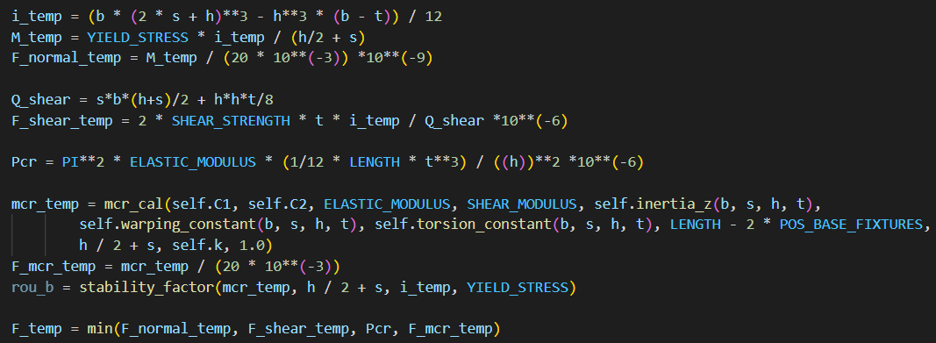

Enumeration algorithm implementation

**For Hollow Rectangular Beam:**

Calculation of F (normal stress), F (shear stress), Pcr, and deriving the ultimate load:

Enumeration algorithm implementation

**Reference**

|  |  |
| --- | --- |
| [1] | E. Oberg, Machinery's handbook, 2018. |
| [2] | Access Steel, "NCCl: Elastic critical moment for lateral torsional buckling". |
| [3] | "Roymech.org," [Online]. Available: https://roymech.org/Useful_Tables/Torsion.html. [Accessed 12 April 2023]. |
| [4] | "Researchgate," [Online]. Available: https://www.researchgate.net/figure/Different-buckling-modes-of-steel-I-beams-a-Lateral-torsional-bucklin-g-b-local_fig1_272639663. [Accessed 12 April 2023]. |